**FACTORIAL**

**OF A GIVEN NUMBER**

**EXP NO: 9**

**AIM:**To find the factorial of a given number using

8085 microprocessor.

**ALGORITHM:**

1) Load the data into register B

2) To start multiplication set D to 01H

3) Jump to step 7

4) Decrements B to multiply previous number

5) Jump to step 3 till value of B>0

6) Take memory pointer to next location and store

result

7) Load E with contents of B and clear accumulator

8) Repeatedly add contents of D to accumulator E times

9) Store accumulator content to D

10) Go to step 4

**PROGRAM:**

LDA 2001

MOV B,A

MVI C,01H

MVI E,01H

LOOP: MOV D,C

MVI A,00H

LP: ADD E

DCR D

JNZ LP

MOV E,A

INR C

DCR B

JNZ LOOP

MOV A,E

STA 2010

HLT

**INPUT:**



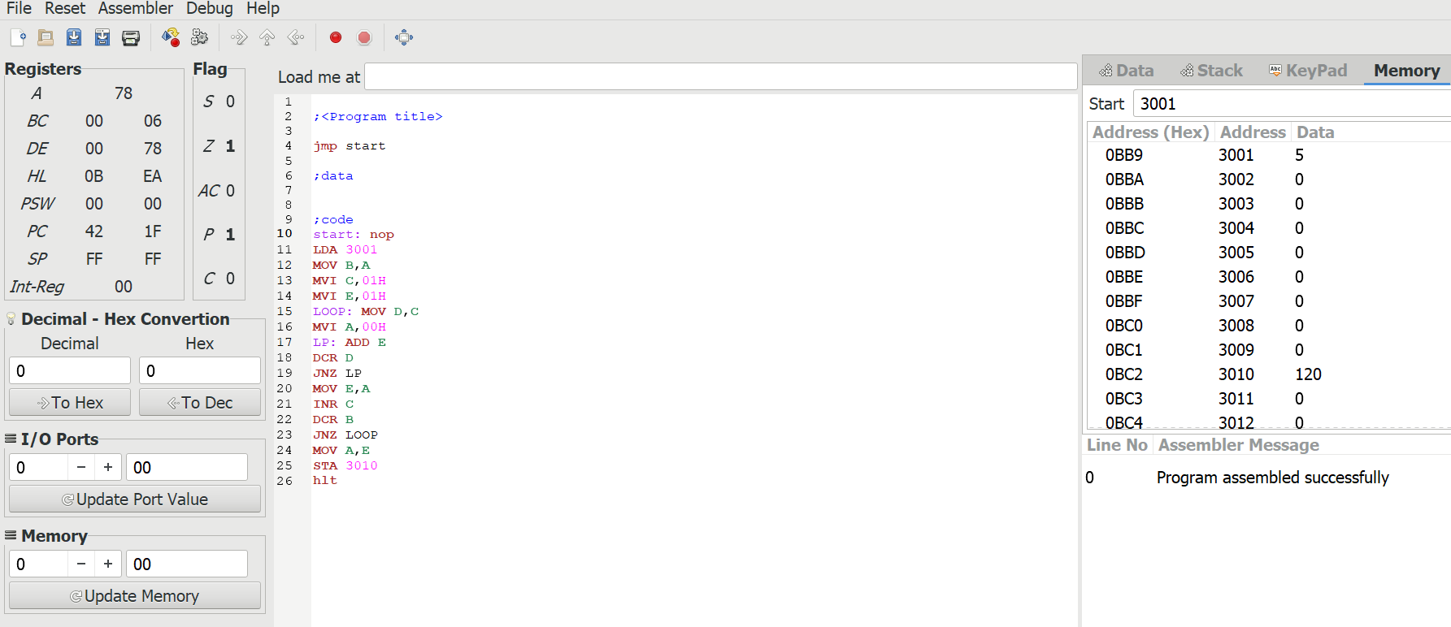

**OUTPUT:**



**RESULT:** Thus the program was executed successfully using 8085

processor simulator.